## Splitty App Project

**Contents**

1. Introduction
2. Business objective
3. Business Analysis Core Concept Model(BACCM)
4. Stakeholder
5. Identify risk strategy- analysis
6. SWOT Analysis
7. Process Map
8. Use case diagram
9. In scope and out scope requirements
10. Requirement analysis
11. Wireframes

**INTRODUCTION**

BW company is known for delivering its apps and services to the people worldwide, to satisfy their needs. Over the course of 15 years it gained the people trust all over the world and emerged as one of the top companies in the tech industry. The company’s expertise lies in creating intuitive and accessible solution to simply the everyday tasks, making life easier for the users.

**Business Objective**

The Bow Company aims to develop an app “Splitty” that simplifies the task of managing and splitting group expenses among the circle. This app will allow users to add bills, track shared expenses ,and manage payment efficiently within groups such as friends,family,or roommates .The company’s goal is to create a user friendly, accessible app in order to reduce the financial misunderstandings among the users and to increase the usage of this app among the common people

**EXPECTED BENEFITS OF THIS APP**

* Simplifies expense management and peer to peer transaction
* Reduce financial disputes
* Ensures transparency in transactions
* User friendly interface

## BACCM: Business Analysis Core Concept Model:

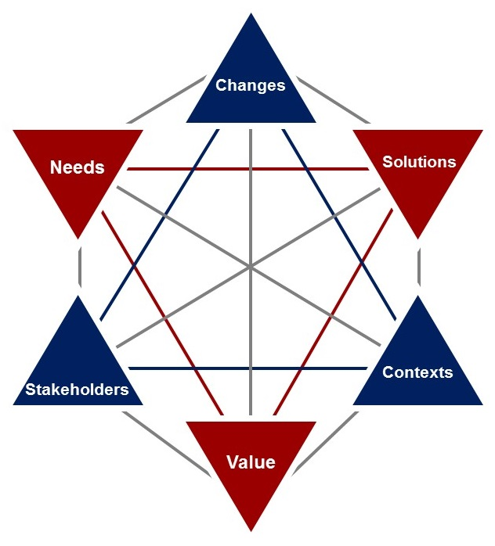

|  |  |
| --- | --- |
| NEED | In today's world most of the transactions takes place in the form of digital payments. There is a need for a trustworthy and user friendly platform to track, split, manage shared expenses and to provide transparency among the groups |
| CHANGE | This application causes a shift form manual tracking of shared expenses to an automated user friendly system, thereby creating a solution to the users problem and improves the ease of living |
| SOLUTION | This application should have the ability to provide a user friendly tracking system for groups and individuals should generate summaries or reports of shared expenses, provide necessary reminders for unsettled accounts. This application should have the ability to satisfy the need. |
| CONTEXT | People across the world were moving towards digital payment method allowing them to easily transfer/receive money among other users using Google Pay,  PayPal etc. This application should be compatible enough to work on android ,iOS |
| VALUE | This application built the trust among the users, By providing clear records-of data and automates the difficult calculations in an easier and efficient way |
| STAKEHOLDERS | **External stakeholders**   * End Users * Sponsors * Google play store(suppliers) * Regulatory bodies ensuring the app adheres to data privacy and security laws   **Internal Stakeholders**   * Business analyst * Domain SME * Project Manager * Tester * Programmer * Operational support * Implementation support |

**STAKEHOLDERS**

|  |  |  |
| --- | --- | --- |
| END USERS | | Common people who use this application in a daily basis to track, split the group expenses and to keep record on their spending |
| SPONSORS | The BW company would fund for the development of this application and controls the budget required for thins creation | |
| SUPPLIERS | **CLOUD SERVICE PROVIDER:**  This application require cloud service providers in order to store large amounts of data  **DATA SECURITY SOLUTIONS:**  Application requires encryption tools provided by third party services | |
| REGULATORS | This focuses on the safeguarding of users data and maintains privacy of the users.  National Institute of Standards And Technology(NIST) ensures the security of the data and prevent from cyber threats | |
| BUISNESS ANALYST | Business analyst is responsible for gathering all the requirements and ensures the entire requirement further converted into proposed systems. Business analyst is responsible for maintaining the proper communication between all the stakeholders | |
| DOMAIN SME | Domain SME should have the in depth knowledge on the topic and will provide the necessary information for the development of project | |
| PROJECT MANAGER | Project Manager are responsible managing the work and to deliver a solution that meets the business need, is also responsible for balancing project factors like budget, scope ,schedule, risk and quality | |
| TESTER | Tester should verify that the given application meets all the requirements provided by the business need and should also check the defects, quality of the application and minimize failures | |
| OPERATIONAL SUPPORT | Operational support maintains the day to day running, maintenance and management of the application | |
| IMPLEMENTATION SUPPORT | Implementation support will check on the proper development of the application without impacting any functioning of the system | |

**ONION DIAGRAM:**

**RISK ANALYSIS:**

**SWOT ANALYSIS:**

|  |  |  |  |
| --- | --- | --- | --- |
| * **strengths** | * **weakness** | * **opportunities** | * **Threats** |
| * Technology * Brand * Price * Customer base * No well-established competitors | * Data privacy * Expenses for add | * Technological development * Digital transaction | * Competitors * Entry difficulties * Regulations * Economic downturn |

**INSCOPE REQUIREMENT:**

* This features should be available in multiple languages and for multiple currency
* Should have the ability to export expense data and details in a spreadsheet to other apps
* This application should allow to invite friends via messages
* Display of the app activity properly to the users
* Should have the ability to notify the users to remind them at specific time to pay the expense split
* Should be user friendly and should have other options to split by percentages and shares

**OUTSCOPE REQUIREMENT:**

* Allowing users to choose avatars or cartoons for the profile
* Complex method of sharing expenses is not the part of this application
* Should ensure quick loading and provide high performance

**BUSNINESS REQUIREMENTS:**

* To increase the usage of this app among the people and to gain trust among the users
* Ability to attract and retain the usage of this app for longer period of time
* To provide a platform which is user friendly and transparent

**STAKEHOLDER REQUIREMENTS:**

* Application should allow tracking of shared expenses and keeping record of data
* Should send automated reminders to unpaid balances
* Need for several options to customize and split the expenses

**SOLUTION REQUIREMENT:**

**FUNCTIONAL REQUIREMENTS:**

* Allow users to create group and add friends
* Allow users to split and categorize the data and store those data legibly
* Allow flexible expose splitting methods
* Should provide timely reminders by sending notifications
* Should send automated Email reports of the monthly summary

**NON FUCTIONAL REQUIREMENTS**:

* Should ensure quick loading and synchronization across the devices
* Should allow multiple users to use the application at the same time without any delay
* UI/UX should be compatible to all the devices

**TRANSITIONAL REQIREMENTS**:

* A team should be set and well trained to handle the customs support and the queries
* Updating the clear FAQ and user guide for the new users
* Revealing new updates in a easily comprehensible way for the users

**PROCESS MAP:**

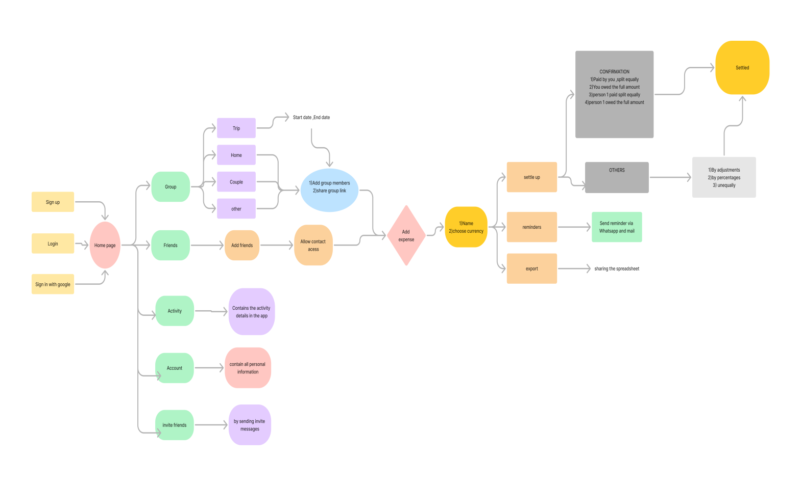

**USE CASE DIAGRAM**

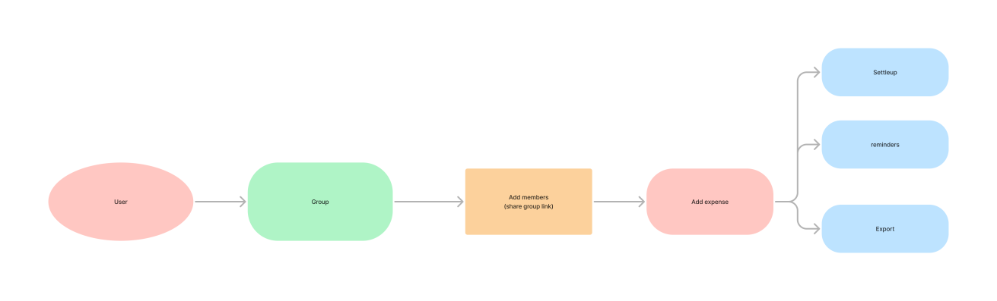

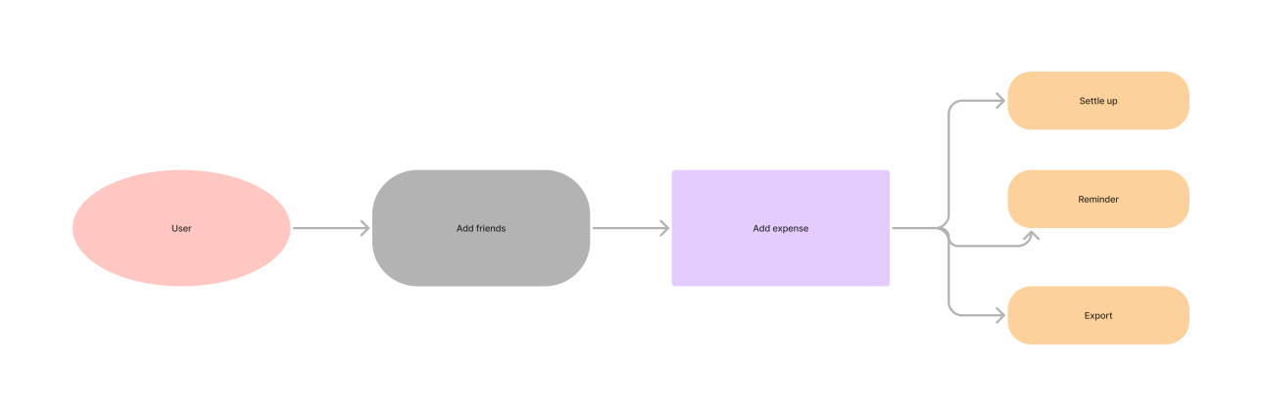

**WIREFRAMES:**

 

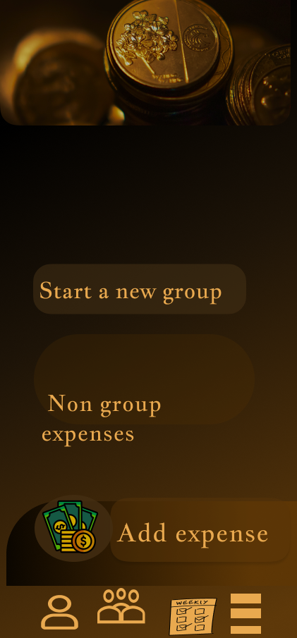 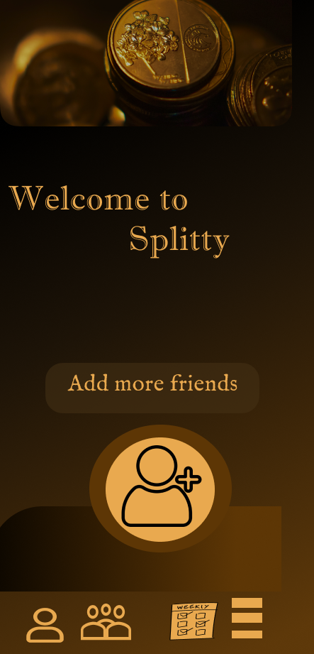

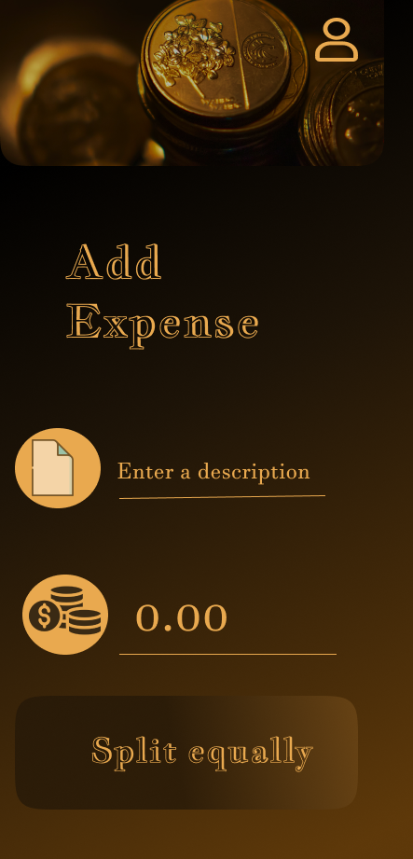 

**PROTOTYPE LINK:**

**https://www.figma.com/proto/fjNsGPAkDqDBzoYavEz4JS/Untitled?node-id=0-1&t=Dp4AXITvqJY7cgrH-1**